**Conceptual Model**

**Conceptual model on seeking consent during vaccination**

  The group will use conceptual model to introduce policy change. A conceptual framework is an illustration of a system that is composed of concepts, which are used to simulate or understand the subject that is represented by the model. The model would be vital in improving individual’s understanding of the importance of seeking consent before vaccination (Wonodi et al. 2012). The conceptual model offers the target population a document that can be used as a reference in future. Vaccination, on the other hand, is an important health strategy that helps to prevent emergence of diseases. Because vaccination is often perceived to be unsafe as a result of the associated side effects, our group would implement the conceptual model bay bringing on board the opinions of all stakeholders including parents, local authorities and opinion leaders in developing a framework for promoting coercion free vaccination. Healthcare providers and policymakers should thus seek consent from an individual before the immunization is conducted (Coker et al. 2013).

  Our advocacy group calls for all medical practitioners and policy makers to seek consent from an individual before initiating vaccination. Ethical concerns about vaccination have span public health sphere, including those of clinicians, policymakers, and many other professionals (Leask et al. 2012). The group, therefore, seeks to advocate for this policy change through a conceptual framework that will target the concerned institutions. As a group, we hope that a conceptual model will help us inform the medical fraternity and the entire population that vaccination should not be mandatory for kids and adults and that they should seek for their consent first before injecting people. People should have a choice on whether to be vaccinated or not. Guardians or parents should have an opinion on whether their children are to be vaccinated.

  Below is a conceptual model for HPV vaccine. The health practitioners involved should seek consent from individuals before it is administered.

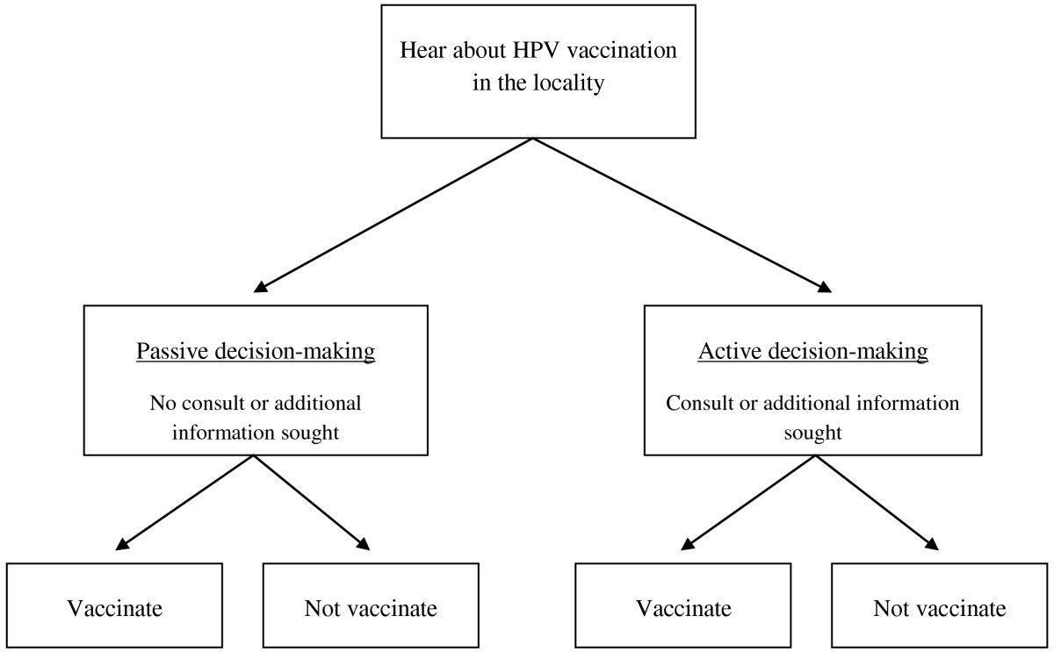

**References**

Coker, R., Rushton, J., Mounier-Jack, S., Karimuribo, E., Lutumba, P., Kambarage, D., & Rweyemamu, M. (2013). Towards a conceptual framework to support one-health research for policy on emerging zoonoses. The Lancet infectious diseases, 11(4), 326-331.

Leask, J., Kinnersley, P., Jackson, C., Cheater, F., Bedford, H., & Rowles, G. (2012). Communicating with parents about vaccination: a framework for health professionals. BMC pediatrics, 12(1), 154.

Wonodi, C. B., Privor-Dumm, L., Aina, M., Pate, A. M., Reis, R., Gadhoke, P., & Levine, O. S. (2012). Using social network analysis to examine the decision-making process on new vaccine introduction in Nigeria. Health Policy and Planning, 27(suppl_2), ii27-ii38.