**Gastrointestinal Tract:  Disorders of Motility**

**Introduction**

The anatomy of the gastrointestinal tract consists of the mouth, the esophagus, the stomach, small and large intestine, and the rectum and anus. The primary purpose of the GI tract is to aid the digestive system in breaking down and absorbing food substances and liquids that are required by the human body to sustain life. Disorders of the gastrointestinal tract such as gastro-esophageal reflux disease (GERD), peptic ulcer disease (PUD), and gastritis can alter gastric acid stimulation and production needed to maintain the function of the digestive system.  It is imperative for the nurse practitioner to have a sound understanding of the mechanisms of these disorders along with other disorders of the GI tract to accurately diagnose and provide effective treatment.  This paper will discuss the changes that occur to gastric acid stimulation and production with GERD, PUD, and Gastritis, how patient factors impact the pathophysiology of these disorders, how to accurately diagnose and treat these diseases based upon the patient factor discussed, and a visual mind map to increase understanding of gastritis.

**Pathophysiology of Gastric Acid Stimulation and Production**

Secretion of gastric acid is done by the parietal cells, which are found in the linings of the stomach. In the human body, the simulation and production of gastric acid take place in the secretory canaliculus, which is the most viable region in the stomach walls for the process to occur. At this area, the PH is alkaline, about 8, an aspect that stimulates the production of gastric acid which is absorbed in the lumen. Gastric acid's secretion has stimulated some processes including merocrine, paracrine, and hormonal messages (Fiocca et al., 2012). Gastrin, produced in the G cells of the pyloric mucosa plays the most significant role in the stimulation of Gastric acid secretion. Various inputs stimulate the parietal cells to secrete hydrogen ions that are useful in the formation of gastric acid. Besides gastrin, Histamine 2 receptors are believed to largely contribute to the production of gastric acid, produced as a reaction response between cholesytokinnin-2 (CCK2) and Parietal cells and enterochromaffin-like (ECL) (Malfertheiner, 2011). When gastrin binds with parietal receptions, it results in the formation of intracellular calcium, which activates the proton pump. Also, histamine is produced when gastrin is attached to ECL to form H2 receptors.

During the stimulation, production, and transmission of gastric acid, there is a constant regulation and balance of chemo transmitters in the digestive system of human being. In this regard, the simulative and inhibitory factors are controlled in a stabilized manner. Overlapping of endocrine, paracrine, autocrine, and neural processes is responsible for the secretion, defense, and healing of the intestinal walls against any gastric acid-related injuries (Fiocca et al., 2012). While the function of gastric acid is yet to be fully understood in most animals, the secretion and storage of the gas in vertebrates is vital for their evolutional characteristics. Besides, the flow of the acid in the body is useful in the digestion of vitamin B12, absorption of minerals such as iron, and digestion of various elements including calcium and vitamins. Production of gastric acid is also essential in the control of bacterial growth and multiplication in the body of human beings. Such mechanisms are important as independent bacterial production may result in enteric infections (Ates & Vaezi, 2014).

**Changes That Occur To Gastric Acid Stimulation and Production with GERD, PUD, and Gastritis Disorders**

One of the most common disorders in the human anatomy is the GERD, which is caused by a reflux of the stomach. The condition is commonly known as a heartburn and is initiated by the secretion of hydrochloric and gastric acids in the stomach and gastric glands respectively. The production of the two acids is accompanied by the secretion of digestive enzymes used in the breakdown of complex food matter into tiny molecules that can be quickly absorbed into the blood system (Ates & Vaezi, 2014). As a natural process, excess or little hydrochloric or gastric acid may be secreted. In this regard, GERD is experienced when there is the overproduction of either or both of the two acids, resulting in a burning sensation. However, excess gastric acid plays a more significant role in GERD situations.

A condition known as PUD is experienced when the mucosal balance of the stomach is disturbed. The disruption causes an inflammation of the intestinal walls leading to a defection of the functionality of mucosal membranes. The pathophysiology of PUD in the body determines whether the condition is acute or chronic. In most cases, PUD is caused by oversecretion of gastric acid and is common in people who have many parietal cells (Ates & Vaezi, 2014). Gastritis disorder is also caused by the amount of gastric acid produced in the stomach. In essence, the condition is a slow or gradual irritation and inflammation of the intestinal walls caused by excess production of gastric acid and insulin. The occurrence of a gastritis condition is preceded by the impediment of mucosal activity as a result of epidermal growth or gas secretion.

**How Patient Gender might Impact the Pathophysiology of GERD, PUD, and Gastritis**

 Even though there is enough research data on the occurrence of GERD in human beings, there is limited information that explanation its variation between male and female genders. However, recent studies reveal a small difference in the signs and characteristic symptoms of GERD in men and women (Nwokediuko, 2012). In this respect, symptoms such as regurgitation, heartburns, and chest pains are more likely to occur in women compared to men. Besides, more women have been diagnosed with PUD compared to their male counterparts. The frequency of GERD and PUD in women has been associated with the production of gastric acid in fluctuating amounts during periods such as pregnancy, which lead to lower mucosal activity control. However, Gastritis is a common disorder in men than women, an aspect that has been linked to factors such as higher alcoholic intake that irritates intestinal walls. Use of anti-inflammatory drugs has been determined as the cause of gastritis in women.

**Diagnosis and Treatment of These Disorders**

Regular screening and gastric gas secretion control is an ideal way for dealing with GERD, PUD, and gastritis disorders in women. Acid-blocking treatment procedures are an effective way of diagnosing the PUD conditions in both men and females. In this regard, change of behavior, surgery, or administration of medical treatment is done if the level of ulcers is high (Jianu et al., 2012). Blood and stool tests, physical examination, review of family and genetic background, and upper endoscopy are used in diagnosis and recommendation of treatment producers for men and women. Anti-acids, anti-biotic drugs, reduction of acidic foods, and intake of Vitamin B12 are ways through which Gastritis is treated in both genders (Fig. 1).

Gastritis Mind Map

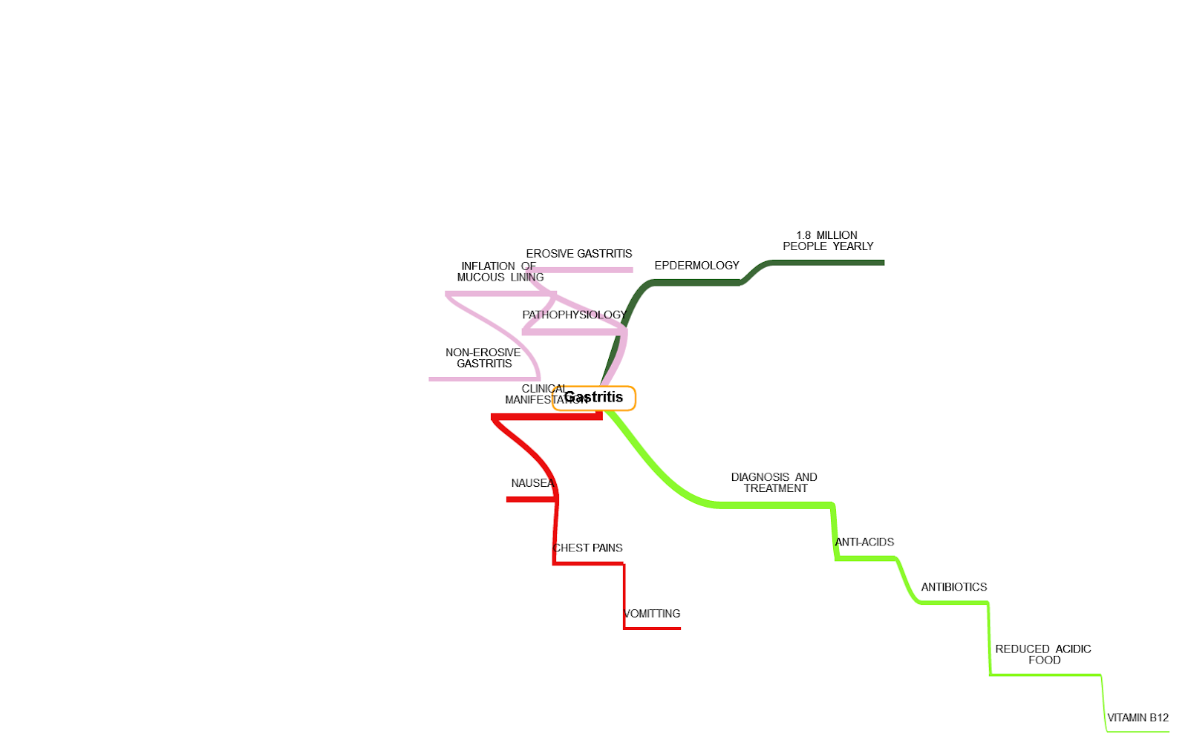

Figure 1: Gastritis Mind Map

**Conclusion**

The discussion provides a clear understanding of the pathophysiological manifestation of GERD, PUD, and Gastritis in human beings. Besides, it is evident that natural and behavioral attributes contribute to the variation in frequency of the three disorders between men and women. However, there are efficient ways through which the conditions can be diagnosed and treated.

**References**

Ates, F., & Vaezi, M. F. (2014). Gastroesophageal reflux disease. Haryana, India: Elsevier.

Fiocca, R., Mastracci, L., Attwood, S. E., Ell, C., Galmiche, J. P., Hatlebakk, J., & Lundell, L. (2012). Gastric exocrine and endocrine cell morphology under prolonged acid inhibition therapy: results of a 5‐year follow‐up in the LOTUS trial. *Alimentary pharmacology & therapeutics*, *36*(10), 959-971.

Jianu, C. S., Lange, O. J., Viset, T., Qvigstad, G., Martinsen, T. C., Fougner, R., ... & Waldum, H. L. (2012). Gastric neuroendocrine carcinoma after long-term use of proton pump inhibitor. *Scandinavian journal of gastroenterology*, *47*(1), 64-67.

Malfertheiner, P. (2011). The intriguing relationship between Helicobacter pylori infection and acid secretion in peptic ulcer disease and gastric cancer. *Digestive Diseases*, *29*(5), 459-464.

Nwokediuko, S. C. (2012). Current trends in the management of gastroesophageal reflux disease: a review. *ISRN Gastroenterology*, *2012*.