**Management Models in NHS Laboratories**

**Introduction**

The NHS laboratory involves experiments of chemicals that might harm human beings if exposed; they have highly experienced and self-motivated chemical engineers and scientists as well as doctors (Roe 2017). The laboratory on a normal hospital is where tests are carried from specimen to gather more information about the health of a person about the diagnosis, prevention, and treatment of illnesses (Van den Berg and Pietersma 2015). Medical laboratory science professionals mostly known as medical laboratorians are imperative healthcare detectives who uncover and provide laboratory information from analysis of a test to aid the physician in treatment and diagnosis. The NHS laboratories form an integral part of the healthcare in the UK; therefore, their management attracts attention from people across the UK and around the globe (Normore 2010). This paper delves on the management models, and ISO standards relevant to the management and training of staff at the NHS laboratory, different leadership roles will be discussed as well and improvement made in the specific staff roles after practice.

Health Management Styles

Effective leadership is imperative to an institution providing healthcare. Leaders play an instrumental role in transforming an institution and streamlining service delivery. Research conducted lately indicated that healthcare organizations tend to thrive and become great organizations recognized internationally because of the leadership. Transformational leadership style has been cited as one of the key leadership styles that are significant and lead to improved control of cost and better healthcare services. Transformational leadership style was related to high performances in an institution though transactional style of leadership was embraced too. Scholars reported that those institutions that had their leaders incorporate both transformational and transactional styles of leadership were slowly becoming the epitome of healthcare.

Health management is the process of coordinating and organizing performances of a healthcare facility. The business and administrative aspect of the institution is supervised by a health care manager. This manager is also responsible for the overall internal system of healthcare including both the non-clinical and clinical staff, government bodies, insurance companies and partner organizations among others. Health care leaders must possess the general leadership skills, analytical abilities, interpersonal skills and a mind-set that is entrepreneurial. With this regard, institutions of higher learning have started programs in healthcare management in order to have healthcare managers who are competent.

**Laboratory Management Structure and Culture**

Most of the NHS laboratories are part of the NHS Trust hence they directly subscribe to the trust. Most of the trust businesses are conducted at a divisional level such that there is the medicine division, emergency, and surgery among others (Yoder-Wise and Kowalski 2010). Pathology serves those above plus many others such as clinics, private hospitals and prisons (Geisler, Krabbendam and Schuring 2013). There is not a definite position for pathology, but wherever it sits in the structure, there is synergy and cooperation between and across both the areas forming that division and the entire organization.

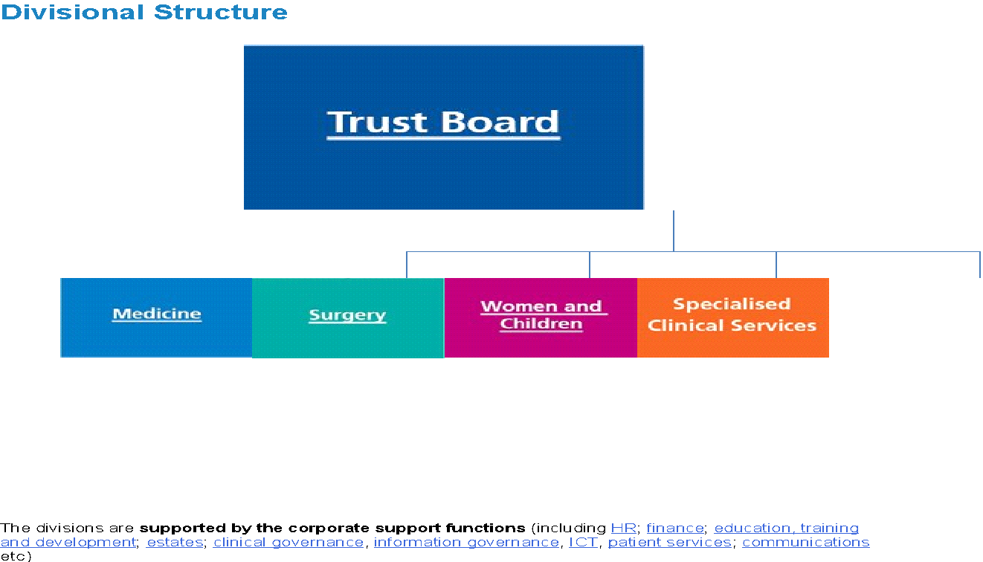 Fig 1: (Jeffries and Battin 2012)

The leadership and management models are made of nine dimensions in which the behaviors are measured in a four-part scale beginning from essential to exemplary (Jeffries and Battin 2012). The complexity and sophistication of management behavior and character increase upwards through the scale, but that is not tied to the levels or job roles (Roe 2017). That means that even those in the junior management level are organized in their scale from essential to exemplary. Leadership behaviors are weighed from questions asked through the scale, and it applies equally regardless of the level of management.

Healthcare at some point applies the standard business management models which are organized in structures and refers to the departments. The laboratory management model is organized hierarchically and captures every department in the laboratory and provide the channel that members of the group will report (Yoder-Wise and Kowalski 2010). A management model consists of two parts, that is the designing, researching and purchasing raw materials and building an item. The second part involves the distribution of the ready items and reaching out to the customers, or the clients prepared to pick up the items.

Leadership and direction are provided by the laboratory top management and is entrusted with ensuring harmony and proper direction to the juniors. The laboratory and general healthcare management are dynamic and complex. Every organization is created to accomplish tasks that are beyond being performed by one person and therefore all the systems have to work together to achieve this purpose (Roe 2017). In a real sense, the healthcare organization deals with the provision of services that are involved and highly specialized disciplines. Managers ensure that organizational goals are achieved, and appropriate resources like human resource and finance are used adequately.

            NHS has suffered recent failures in delivery of quality services to the patients. A study was conducted to identify the problem involved, and the report indicated that the leadership was the issue. The laboratory leaders had to answer to the senior facility managers the question that resulted in general sluggishness in service deliver. It is clear that an organization without good leadership is bound to fail.

            Most NHS Trusts seem to follow a triumvirate senior divisional structure consisting of the Matron, Clinical Lead, and Divisional Manager. Individual areas are usually set up in directorates of which in themselves have an appropriate structure to provide the high-level management of the directorate (Roe 2017). There is often another structure that is similar to the divisional structure; clinical lead, matron or technical lead and directorate manager. The last two positions are often held by one person because of the drive to have more for less (Rogers 2017). The main purpose of the division is to affect both the pathology and the wider trust organization.

**Impact of Leadership and Management on Service Delivery**

**Lab Management Roles**

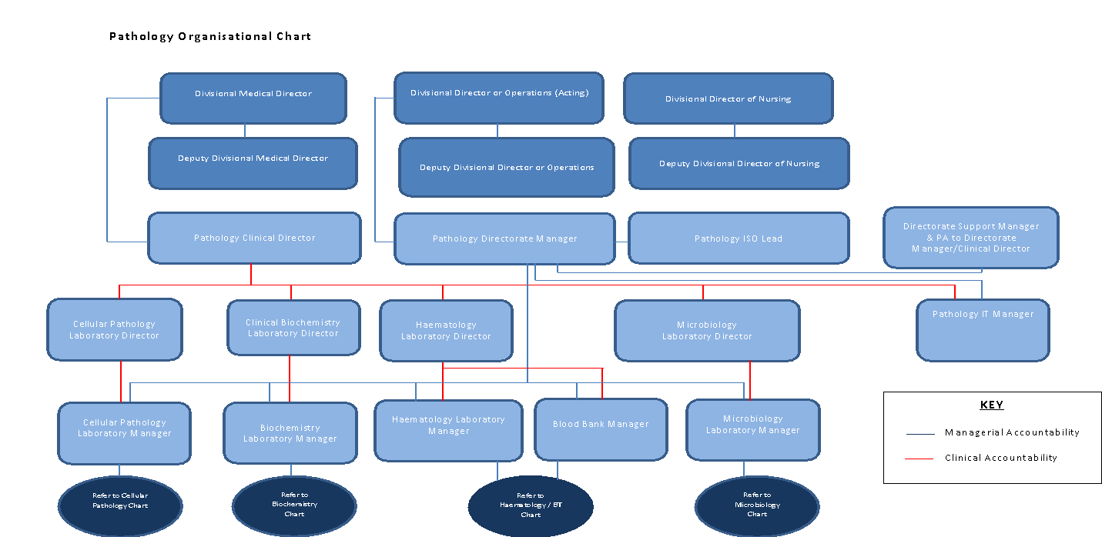

Fig 2: (Normore 2010)

The senior management is headed by the divisional heads which form the executive committee of pathology. Every department as shown in the structure above is independent and reports directly to the divisional manager. However, the entire department has to work in harmony to achieve the sole purpose of the NHS labs department. The health department relies heavily on pathology for discoveries, diagnosis, treatment, and control of illnesses (Normore 2010). The medical department has its future well planned out with the help of the managers. A competent manager should have their eyes fixed on the goals and objectives of the division and to understand the strategic plan that is drawn for future reference.

**Individual Roles in Lab Management**

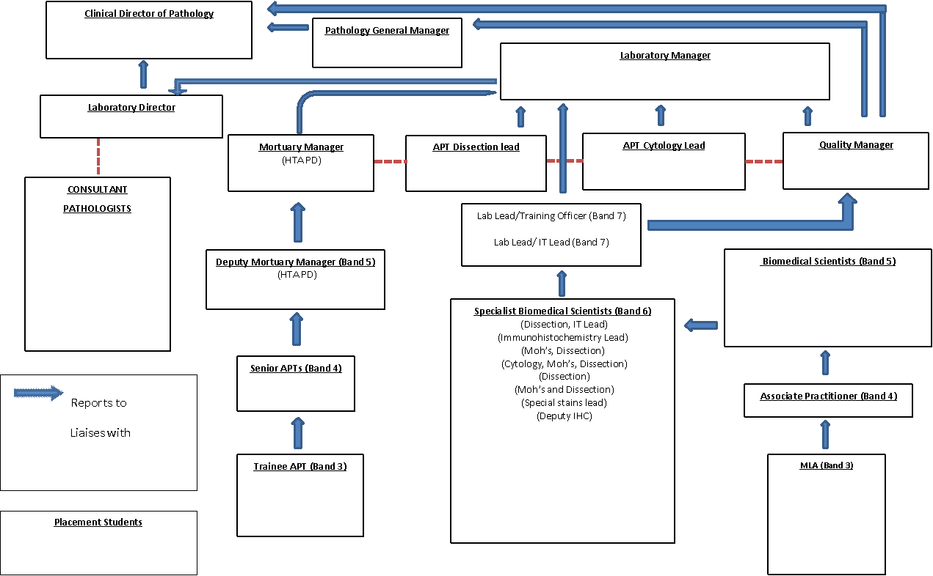

**Fig 3:** (Yoder-Wise and Kowalski 2010)

**Technical Laboratory Manager**

A laboratory manager supports all the programs that are delivered in the laboratory. He leads and takes overall responsibility for the technicians whose role is to provide technical guidance and support for the staff and students. The manager should effectively communicate to all members pathology whether the active or the silent players. He ensures harmony, cohesiveness and good interactions with individuals working in the department (Yoder-Wise and Kowalski 2010). He communicates issues in the technical department and ensures they are rectified. These managers oversee the demonstration instructions for learners training to work in the laboratories. The technical team provides a timely and helpful reactive service to the requests of the staff regarding research. He ensures independent decisions are made concerning operations of the day-to-day operation of the technical team.

**Clinical Director**

A clinical director is expected to serve in the docket for three to five years, he or she reports directly to the medical director and is accountable to the chief executive. The clinical director provides clinical leadership for the directorate, to make sure that the support and efficient management of clinical staff are done efficiently (Lock 2017). He or she is responsible for adequate clinical governance arrangements in the directorate. He offers a legal counsel of the director of nursing and operational services and medical director on issues such as staffing, practice, education, and training (Stark, 2015). Their chief responsibility is to provide clinical leadership to all senior staff. He ensures that adequate arrangements for the safety of patients are made across the directorate. He works in partnership with the directorate of operations to bring about joint accountability for contractual performance, clinical performance, operational performance and financial performance.

**Bank medical Labs Assistant**

The blood sciences manager is accountable to the laboratory manager and responsible to Senior MLA and central services team leader (MULDERS 2016). This leader assists in the work of the department of blood sciences through undertaking clerical and routine technical duties. In all areas of activity, competency, ensured only through training and records kept safely. His chief responsibilities include taking receipts of and sorting clinical samples received from clinics and wards practitioners (Normore 2010). He unpacks the samples concerning the safety and health procedures. He ensures weekly orders are placed in pathology stores and maintain sufficient levels of lab consumables. He is expected to continue a safe and clean working environment using appropriate cleaning materials and disinfectants.

No clinical duties required of this post but they need to have the know-how of running the post (Lock 2017). They carry out work in the laboratory as expected or required by different sections of the laboratory. They ensure that all samples and request papers meet the minimum requirement set by the policy. He is supposed to be IT literate and understand the departmental IT policies. These IT systems are integrated into the system to identify patients, sample results and search correct dates (Malik and Malik 2010). As for the clerical and administration, the officer should produce copies of patients, transfer incoming inquiries to the relevant disciplines. The post does not require any managerial skills, but the individual should often be trained to perform their duties adequately.

**The 5 Key Tasks of the Management**

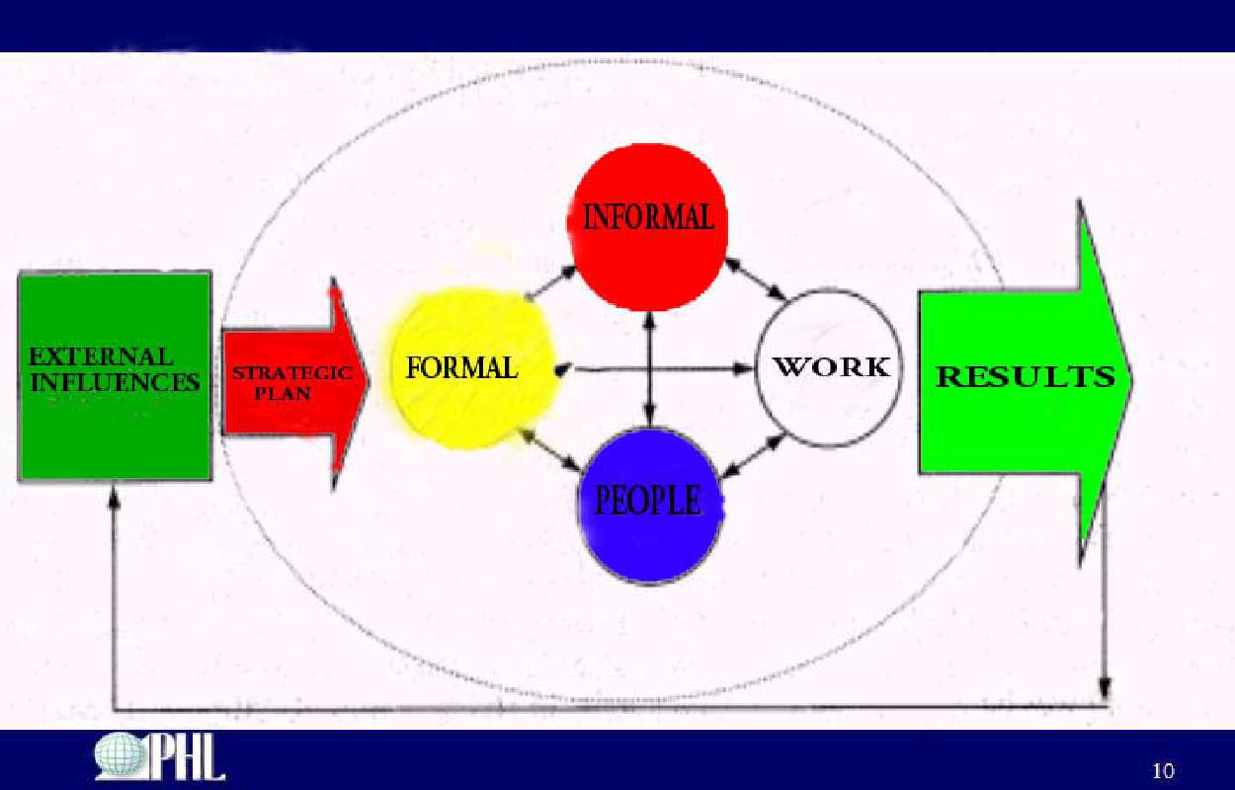

Fig 4: (Cameron 2016)

**Skills Framework and the Agenda for Change**

The five critical tasks of the management include planning, directing, organizing, coordinating and controlling.

**Planning**

The preparation function of organisation controls general plan that allows smooth operation of the organization. Planning means defining goals and coming up with practical courses of achievement needed to achieve the goal (Cameron 2016). Planning involves suppleness since the developer has to organize with all heights of organization and control in the organization. The manager identifies goals and objectives of the laboratory and established policies for lab operations. Planning also entails acquiring data for decision making and estimating the needs for personnel, equipment, and space. Preparing a budget is part of the planning process as well.

**Organizing**

A laboratory manager organizes activities and tasks that will be conducted by the individuals in the division. The organizational development is implemented and clear lines of communication established. The overall structure of the organization is organized by the managers (Cameron 2016). The administrative structure makes the substance of pathology, and deprived of this edifice, the normal operations of the business become unsuccessful.

**Directing**

Managers of the pathology department of the NHS coordinate communication, access external resources and facilitate meetings (Cameron 2016). The managers have a duty of assigning responsibility to the juniors with the aim of attaining the goals and objectives of the organization.

**Controlling**

A laboratory is involved in so many activities which require caution thus a leader has to be conversant with the general rules of the lab. He or she must adhere to the standards within the lab and control the facility. He should be able to rectify issues that appear challenging to the daily work. Making financial decisions should not be a problem to the manager because he will be required to check of things and make purchases severally.

**The ISO Standards**

  ISO 15189:2012 was prepared by Technical Committee ISO/TC 212 to be applied in the vitro diagnostic test systems and clinical laboratory testing. This version cancels and replaces ISO 15189:2007 which was revised technically. This International Standard sets out the requirements for competence and quality. It specifies the quality management system requirements for medical laboratories specifically. Though it has its origin from the ISO/IEC 17025 and ISO 9001, it studies the precise needs of the therapeutic field and the importance of therapeutic laboratory to cater for the patients.

    ISO 9001:2015 addresses the aspects of quality management and this, is the only standard that can be certified nevertheless it is not a condition. ISO 9001 can be cast-off by any organization irrespective of the scope, field of action or the region. The ISO 9001: 2015 ensures that customers get consistently good quality products and services.

     ISO/IEC 17043: 2010 indicates general requirements for the providers regarding proficiency schemes of testing and operation and development of proficiency testing schemes. The conditions are specific for the technical terms such as a medical field in this case. The general requirements for medical laboratories are ensured in writing and certification by this ISO/IEC.

     The ISO/IEC 17025:2005 spells out the general requirements for the competence to undertake the calibrations and test including sampling. This involves all tests and calibrations conducted using lab-developed methods, non- standard and standard methods (Feldman and Greenberg 2015). This ISO applies to all organizations that are involved with tests.

     ISO/IEC 17025:2005 applies to all institutions and research laboratory irrespective of the quantity of personnel (Facilities for pathology services 2005). The degree of the scope of calibrating does not matter as well however the requirements of the clause fail to apply if one of the activities required for the trial such as sampling is missing.

**Training**

Leaders are expected to receive regular exercise regardless of the nature of functions that one plays in the organization. Every department in the organization acts as an organ, conducting independent features but for the good of the entire organization. If one division fails, then the outcome will not be pleasant. The NHS management was reported as failing in the 21st Century (Goldenberg 2013). A research was conducted to check on the issue, and it was reported that the NHS had no shortage of leaders instead it had too many leaders. Leadership programs were present at the cost of millions, but the employees were not secure. Despite the expensive training and all that the Human Resource Management tried to do, the productivity remained below the target line (Lock 2017). The problem was later resolved, and more training was needed to equip the employees who would steer the organization back its glory. Training is an essential aspect of every organization, and it should be carried out regularly.

If the laboratory technicians and other employees fail to subscribe to the laws that are present in the laboratory as per the ISO, problems and significant errors occur. Non-conformances have previously affected the regular running of the laboratories especially the major labs in the world. A laboratory is a uniquely sensitive zone where precision is not negotiable. Everyone is expected to act with great sobriety and observe primary rules and regulations of the laboratory. Every employee plays a different role from the other hence people should be keen on their work and keep their positions with caution.

The lab manager should be highly trained and qualified to take responsibility for the laboratory and the human resource. The staff ought to have sufficient numbers of staff with diverse qualifications to handle lab operations efficiently and adequately. The departmental heads are supposed to check for areas where the junior employees need to be further trained. Where errors have occurred continuously, employees should be trained on that and guided through the processes to ensure the issue does not recur.

The competency-based training programme supports multidisciplinary working in the laboratory. This training programme has also been used to identify professional development needs both at the organizational or personal level. Frequent assessments are helping in the event of a professional growth plan which could facilitate enhanced satisfaction and staff engagement. Some of the resources used for workforce assessment include competencies assessment database which identifies training needs through evaluation of behavioral statements, task-level, and tier-level statements. The other one is competencies assessment excel tool which allows the staff to assess their skills, knowledge, and abilities through competency statements. The WHO laboratories are frequently conducting the competency assessment programmes because they are involved in significant studies that affect the entire world.

**The Seven Pillars of Clinical Governance**

**Clinical effectiveness and Research**

This pillar of clinical governance is involved in finding answers to what works in the healthcare or medical field. Finding out what works includes getting a quick recovery, symptom relief, or getting a longer life. Clinical effectiveness is tested using experiments which single out the precise effects of actions.

**Clinical Audit**

Clinical audit refers to the way medical practitioners including doctors and nurses can quantify the quality of the care they provide. The audit provides a scale through which the medical practitioners compare their performance against the standard to identify areas that need improvement or find out opportunities. Other than the general audit, personal audits for individual members are also present.

**Risk Management**

Risk management in healthcare involves what has a possibility of going wrong during care but does not. Looks into the factors that influence the risks and exploring them conclusively. Risk management is well monitored when health care facilities and practitioners learn lessons from the adverse effects that have happened to other institutions. In case of any risk occurrence, caution should be taken to ensure no recurrence happens.

**Education and Training**

The medical field is broad and requires knowledgeable practitioners to perform a good job. Medical field staff is taken through training sessions which provide an opportunity to update their skills, learn new ones and familiarise with the latest developments.

**Patient and Public Involvement**

The quality of service and maintaining high standards of operation in the healthcare department is done by involving the public and the patients. Healthcare facilities are expected to provide services that are patient-oriented. Independent public bodies in the healthcare facilities have facilitated the involvement of patients and public in local decision-making.

**Using information and IT**

NHS organisations involved in the delivery of quality services and protecting the high standards of care. These organisations have achieved this by putting up and organising environments that will facilitate excellence in healthcare. Information and technology are applied in all the processes of healthcare, from diagnosis to prescription. IT has broadened the minds of individuals and made healthcare processes more straightforward and efficient.

**Staffing and Staff Management**

This is a strong pillar in the delivery of services in the healthcare system. To maintain the standards and a high degree of service delivery in healthcare. Semi-qualified staff is likely to cause errors while treating patients at the health centres.

**Conclusion**

In conclusion, the NHS laboratory falls under the pathology department which has several divisions. The department is referred to as an organization because of its operations that are joined together to present the best outcome. Every division works towards realization of the common goal of the organization and for that to happen, the management has to be on check. Over the past two decades, the NHS management has been questionable because of the various errors that were continuously done. The primary objectives of the entire ministry were not being realised because of failures in management and leadership. However, over the past five years NHS has shown great improvement and research shows that the change is attributed to new leadership. Having the right leaders in any organization is the basic thing that every business should strive to achieve. The NHS laboratories have a leadership structure that is hierarchical. Such forms of structures are recommended in organizations that have numerous independent departments for easier monitoring and realization of the objectives.

**Bibliography**

Cameron, E. (2016). *Making sense of change management*. [Place of publication not identified]: Kogan Page Stylus.

Chang, E. and Daly, J. (2015). *Transitions in Nursing-E-Book. Preparing for Professional Practice*: Elsevier Health Sciences.

Feldman, H. and Greenberg, M. (2015). *Educating nurses for leadership*. New York: Springer Pub. Co.

Geisler, E., Krabbendam, K. and Schuring, R. (2013). *Technology, health care, and management in the hospital of the future*. Westport, CT: Praeger.

Goldenberg, S. (2013). *Epidemiology and diagnostic testing for Clostridium difficile in a UK teaching hospital*.

Gunter, H.M. (2016). *An intellectual history of school leadership practice and research*: Bloomsbury Publishing.

Jeffries, P. and Battin, J. (2012). *Developing successful health care education simulation centers*. New York: Springer Pub. Co.

Kalshoven, K. and Taylor, S. (2018). Leadership. Philosophical Perspectives and Qualitative Analysis of Ethics—Looking Back, Looking Forward, Looking Around: *Journal of Business Ethics*.

Lock, D. (2017). NHS leaders are failing to" speak truth unto power". *BMJ: British Medical Journal (Online)*, *356*.

Malik, F. and Malik, F. (2010). *Management*. Frankfurt [Germany]: Campus Verlag.

MULDERS, M. (2016). *101 MANAGEMENT MODELS*. [Place of publication not identified]: TAYLOR & FRANCIS.

Northouse, P.G. (2018). *Leadership. Theory and practice*: Sage publications.

Normore, A. (2010). *Global perspectives on educational leadership reform*. Bingley: Emerald.

Parkay, F.W. Anctil, E.J. and Hass, G. (2014). *Curriculum leadership. Readings for developing quality educational programs*: Prentice Hall.

Roe, K. (2017). *Leadership*. Oxford: Oxford University Press.

Rogers, H. (2017). *The work of the NHS Institute*. [Bradford, England]: Emerald.

Stark, J. (2015). Product lifecycle management. In *Product Lifecycle Management:* Springer, Cham.

Van den Berg, G. and Pietersma, P.  (2015). *Key management models. the 75+ models every manager needs to know*: FT Press.

Yoder-Wise, P. and Kowalski, K. (2010). *Leadership*. Philadelphia, PA: Saunders.